Computer Science & Information Systems

**Real Time Analytics / Stream Processing & Analytics**

**Apache Storm Lab Sheet 3**

**WordCount Application with Storm**

1. Objective:

Students should be able to

1. Get familiarity with the working of Storm Application
2. Get hands-on experience writing Java program for Streams processing using Storm Topology consisting of Spout and Bolts

The logic for a real-time application is packaged into a Storm topology. A Storm topology is analogous to a MapReduce job. One key difference is that a MapReduce job eventually finishes, whereas a topology runs forever (or until you kill it, of course). A topology is a graph of spouts and bolts that are connected with stream groupings. The stream is the core abstraction in Storm. A stream is an unbounded sequence of tuples that is processed and created in parallel in a distributed fashion. Streams are defined with a schema that names the fields in the stream's tuples. By default, tuples can contain integers, longs, shorts, bytes, strings, doubles, floats, booleans, and byte arrays. You can also define your own sterilizers so that custom types can be used natively within tuples.

A spout is a source of streams in a topology. Generally spouts will read tuples from an external source and emit them into the topology (e.g. a Kestrel queue or the Twitter API). Spouts can either be reliable or unreliable. A reliable spout is capable of replaying a tuple if it failed to be processed by Storm, whereas an unreliable spout forgets about the tuple as soon as it is emitted. All processing in topologies is done in bolts. Bolts can do anything from filtering, functions, aggregations, joins, talking to databases, and more. Bolts can do simple stream transformations. Doing complex stream transformations often requires multiple steps and thus multiple bolts. Part of defining a topology is specifying for each bolt which streams it should receive as input. A stream grouping defines how that stream should be partitioned among the bolt's tasks.

This lab sheet will introduce students with usage of Storm Topology with Java. The application that will be taken as example is word count application. The topology will consist of a spout and two bolts. The spout will serve as abstraction for the real world. Its responsibility is to provide a sentence at random from the given list of sentences. The assumption made here is that the sentences are the records received from the real world. Spout is helping us to accept them and making it available for further processing. The first bolt is the topology will be responsible for splitting the sentence into words and forwarding the words to the next bolt. The last bolt will keep track of the count of the words it has received as input. The topology of the word count application can be visualized as shown below.



1. Steps to be performed:

Note - It’s assumed that student has made a slot reservation using the slot booking interface where Apache Storm framework was selected. The details of the Apache Strom systems to be used is received through an email. If not, please contact the administrators for the same.

Also it’s assumed that students are aware of the process of logging into these virtual machines. If not, then get access to the user manual maintained for the usage of remote lab setup.

1. Open the terminal by right clicking on the desktop of the virtual machine.

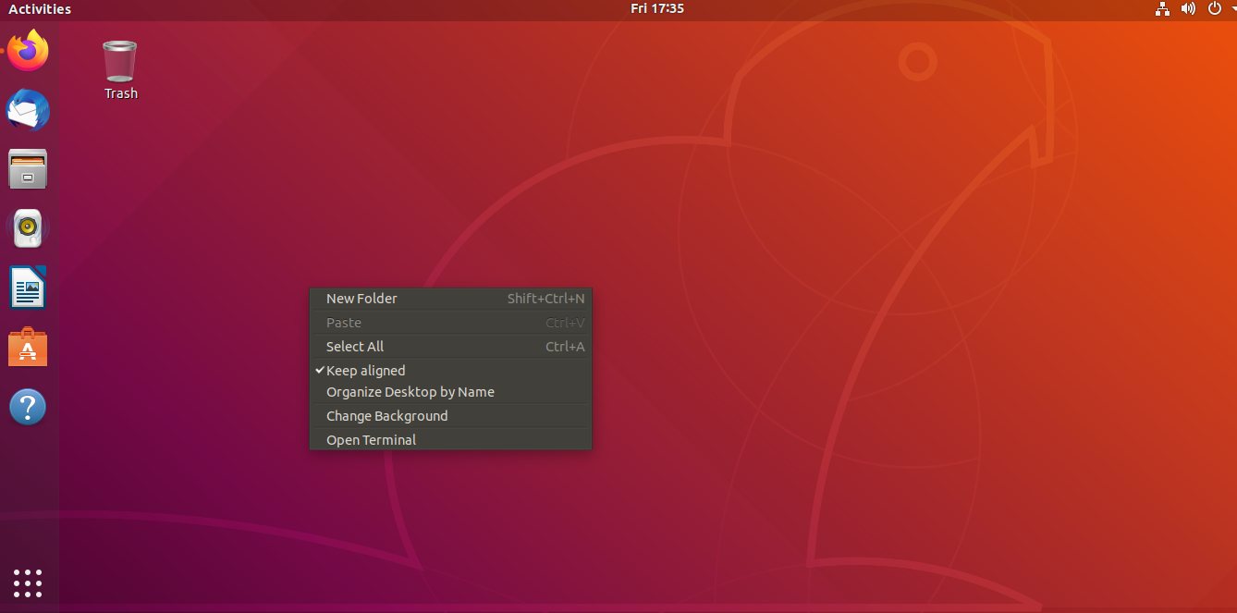

1. Login as sudo user.

>>> sudo su

Provide the password provided in the email received from BITS remote lab team.

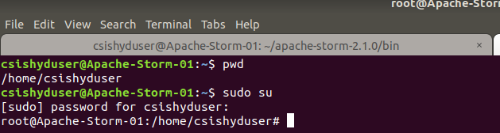

1. Look at the current working directory using the “pwd” command. Then change the directory to the Zookeepers bin directory.

>>> pwd

>>> cd zookeeper-3.4.14/bin/

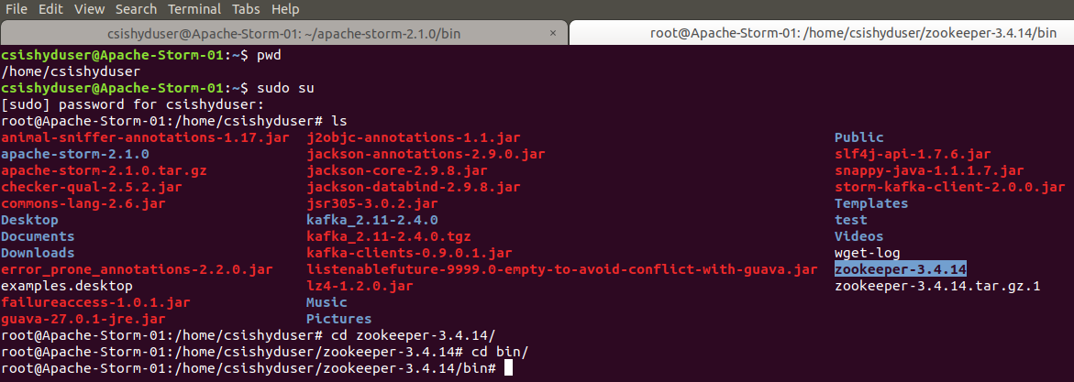

1. Start the zookeeper.

>>> ./zkServer.sh start

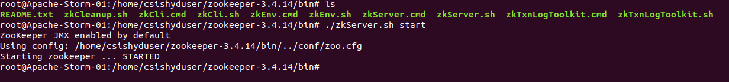

1. Open another terminal. Look at the current working directory using the “pwd” command. Then change the directory to the Storms directory.

>>> pwd

>>> cd apache-storm-2.1.0/

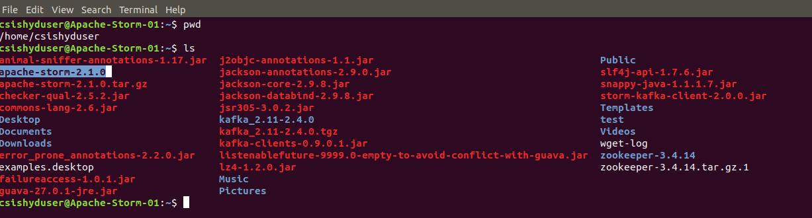

1. Start the nimbus node using the storm command.

>>> bin/strom nimbus

Note – if the command fails, then login as sudo su and then try again.

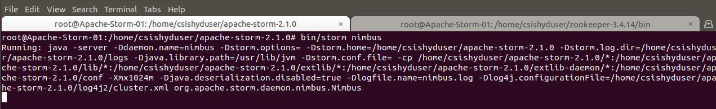

1. Open another terminal. Look at the current working directory using the “pwd” command. Then change the directory to the Storms directory.

>>> pwd

>>> cd apache-storm-2.1.0/



1. Start the supervisor node using the storm command.

>>> bin/strom suporvisor

Note – if the command fails, then login as sudo su and then try again.

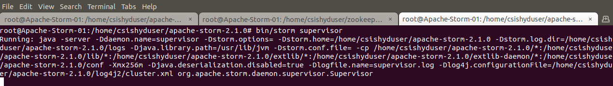

1. Open another terminal. Look at the current working directory using the “pwd” command. Then change the directory to the Storms directory.

>>> pwd

>>> cd apache-storm-2.1.0/

1. Open up gedit editor for writing the Java code.

>>> gedit WordCountTopology.java&

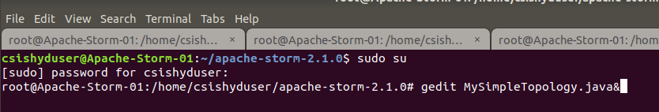

1. Copy paste the content of attached WordCountTopology.java file into the file opened in the geditor.

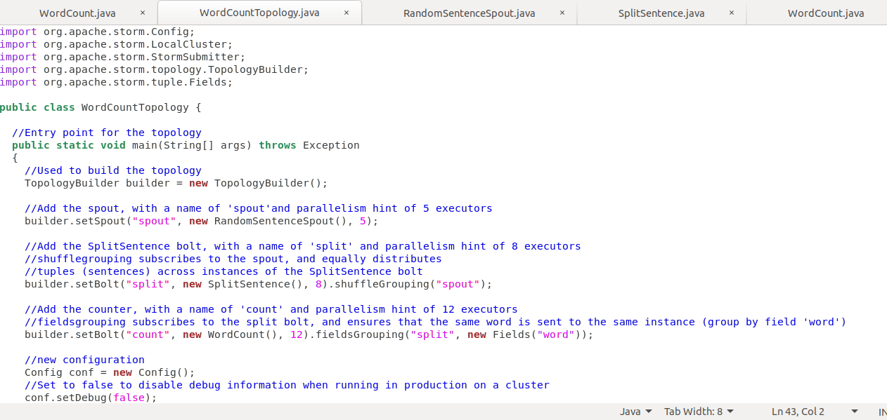

1. Repeat the step J and K for two other java files namely

* RandomSentenceSpout.java
* SplitSentence.java
* WordCount.java

1. Compile the MySimpleTopology.java class which has the topology definition.

>>> javac -classpath .:./lib/* WordCountTopology.java

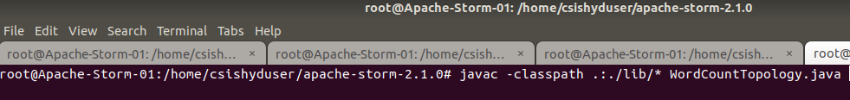

1. Run the MySimpleTopology Storm application and observe the output.

>>> java -classpath .:./lib/* WordCountTopology

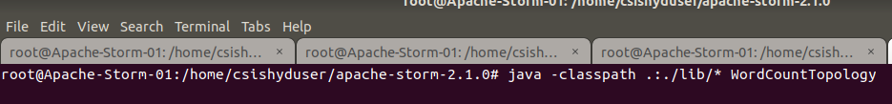

1. In the output you must be seeing the lines shown below which shows that the random sentences is generated in the Spout and getting processed with the Bolt defined where its broken down into the words and then the count of them is getting printed on the console.

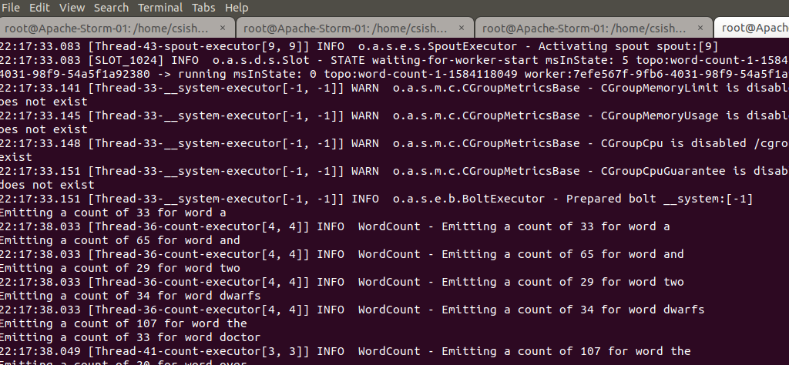

1. In order to run the code continuously comment out the following line in the WordCountTopology.java file, recompile and execute the program to see the continuous output.
   * cluster.shutdown();
2. Outputs/Results:

Students should be able to write a Storm application

* To read the tuples / records from the external sources through Spout
* To do word counting on the tuples through the Bolt logic
* To execute the Storm Topology on the local cluster

1. Observations:

Students carefully needs to observe the code written for the usage of Storm API for

* Building the Spout and data handling with it
* Writing the Bolt and process the data with it
* Building the topology with Spout and Bolt and executing it on cluster

1. References:
2. [Storm Documentation](https://storm.apache.org/releases/2.1.0/index.html)
3. [Strom Tutorial](https://storm.apache.org/releases/current/Tutorial.html)